DEPARTMENT OF THE AIR FORCE

31ST FIGHTER WING (USAFE)

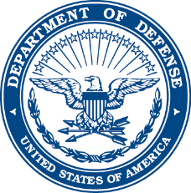

6 December 2024

MEMORANDUM FOR IL COMANDANTE DELL’AEROPORTO “PAGLIANO E GORI”

FROM: 31 Sq/CC

SUBJECT: Exception to Policy Request – Base Access Procedures for United States Personnel

1. The Italian Air Force policy requiring a 30-day coordination for visitor access to Aviano AB was unable to be complied with. The requesting member/unit is seeking approval for an exception to this policy for the below reason/justification:

1. To avoid adverse mission impacts.
   1. EXPLAIN MISSION IMPACT or choose Option B.
   2. If this option is not chosen, either delete entirely or mark as N/A.
2. To avoid adverse family, childcare, or medical impacts.
   1. EXPLAIN FAMILY IMPACT or choose Option A.
   2. If this option is not chosen, either delete entirely or mark as N/A.

2. The requesting member and visiting party’s information is located below:

1. Visiting Member(s): LAST, First M.I.; LAST, First M.I.; LAST, First M.I.
2. Dates of Visit: START to END DATES (10-Feb-22 to 15-Feb-22)
3. Member submitting the IAR:
   1. Full Name:
   2. E-mail:
   3. DSN:
   4. Cellphone number:

FIRST M.I. LAST, RANK, USAF

Commander